Topic of the project:

Project name: "ASIC design with open source tools"

Developing of an low resolution ADC. As example an 4-Bit ADC with conversion of the thermometer code into binary code.

# Steps: A small CMOS inverter with xschem and the sky130a technology (PDK) and simulate the circuit with ngspice:

**Binary Logic level assumption**

<https://en.wikipedia.org/wiki/Logic_level>

|  |  |  |  |
| --- | --- | --- | --- |
| Technology | L Voltage | H Voltage | note |
| CMOS | 0 to 30% of Vdd | 70% of Vdd to Vdd | Vdd = Supply voltage |
|  | ≈0.5 Volt | ≈1.25 Volts | Vdd = 1.8 Volts |

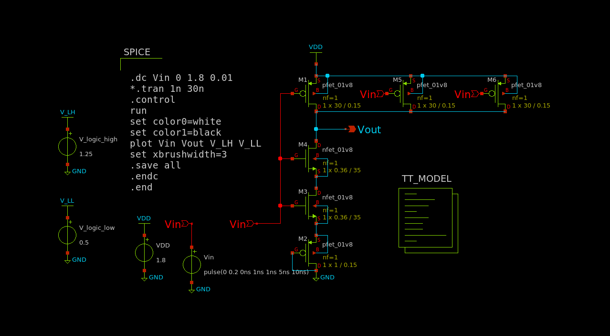

The above figure is the schematic for 15th threshold point of the analogue part of the ADC. The plot is as follows:

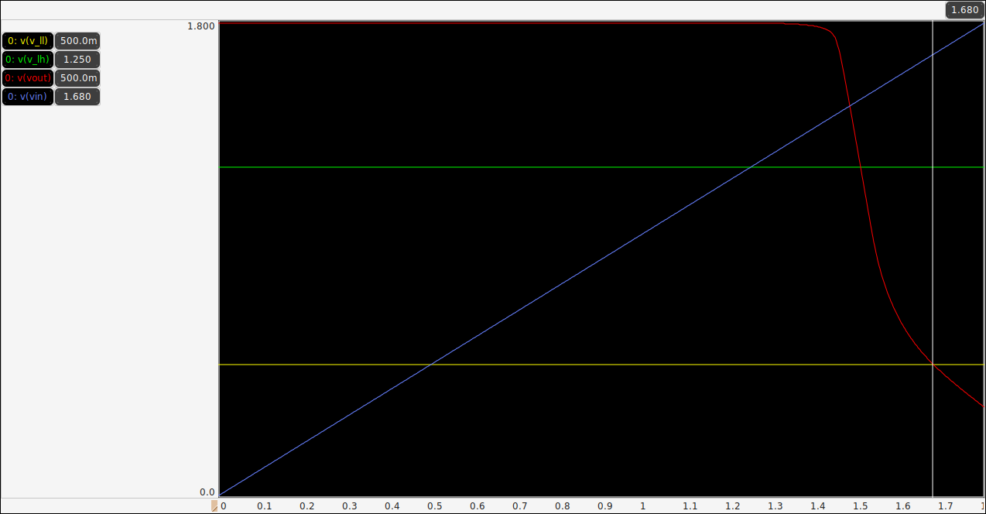

The inverter will switch from logic-high or undefined to logic-zero when input voltage exceeds 1.68 volts. So, for this inverter the threshold is 1.68 volts.

For a 4-bit ADC we need 16 voltage level including zero (0~1.68 volts). The quantization should be 1.68/16=0.112 volts.

**Vdd = 1.8 V**

**Th. 15: 1.680**

For calculation the schematic and the plot already mentioned earlier. Remove all source to make symbol from schematic. As the symbol will have to be connected to Vdd and GND, those pins are replaced with Vp and Vn accordingly.

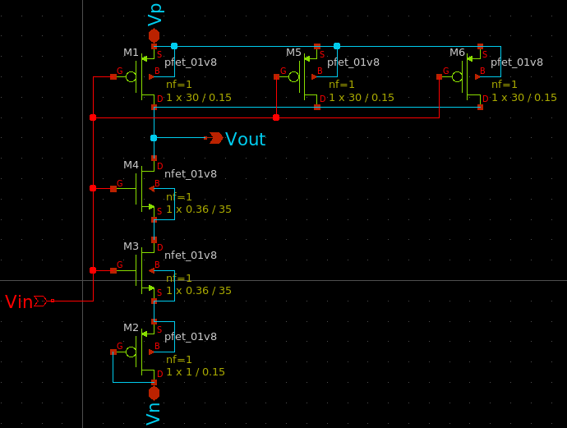

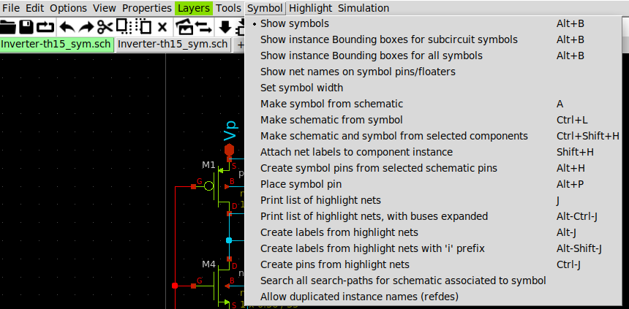

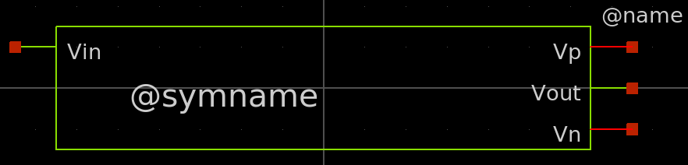

Magic=>before importing netlist to ngspice check LVS net

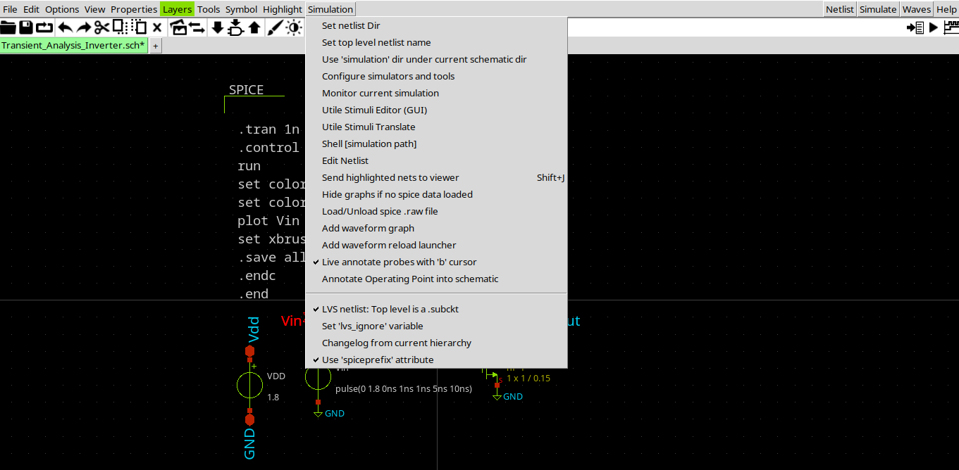

The simplified schematic is as follows:

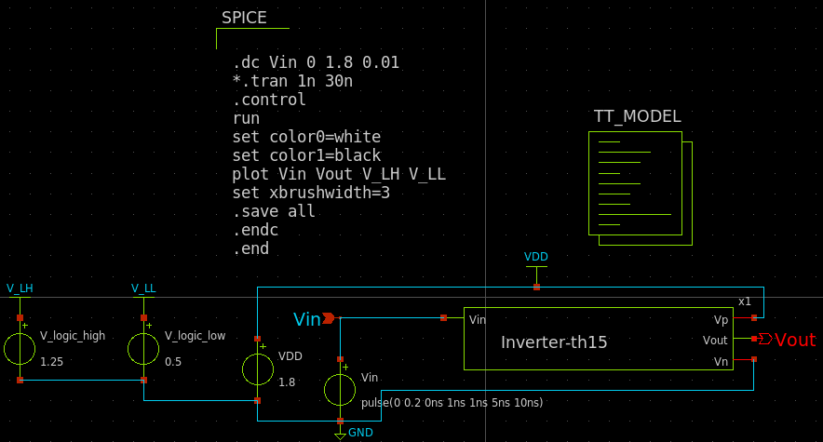

The plot is similar to the previous figure.

**Th. 14: 1.568**

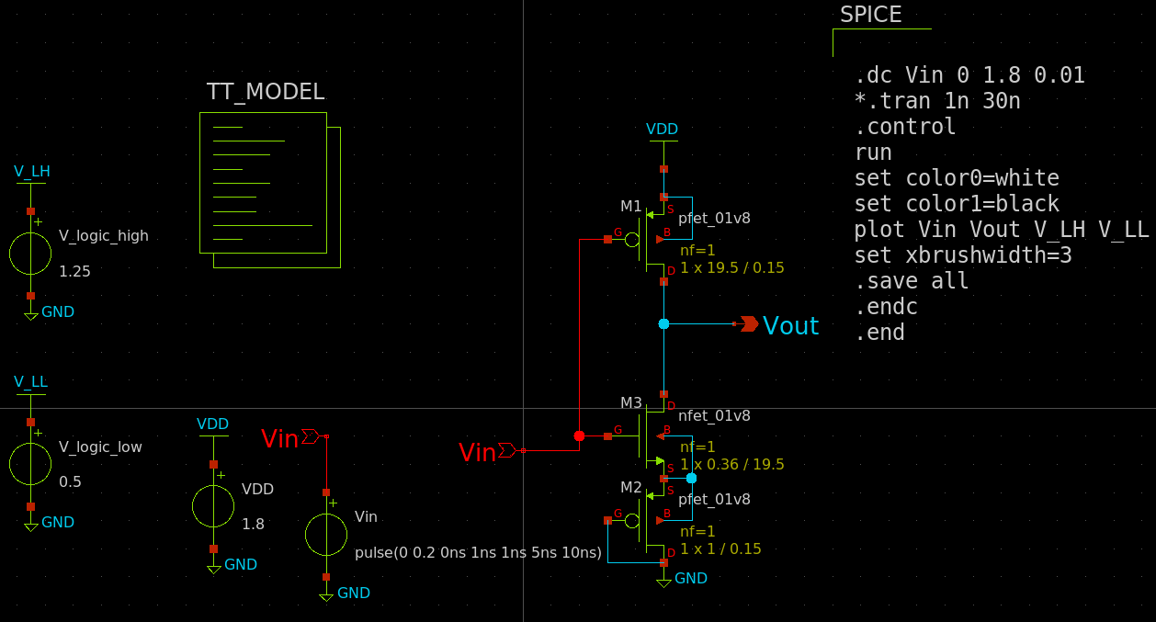

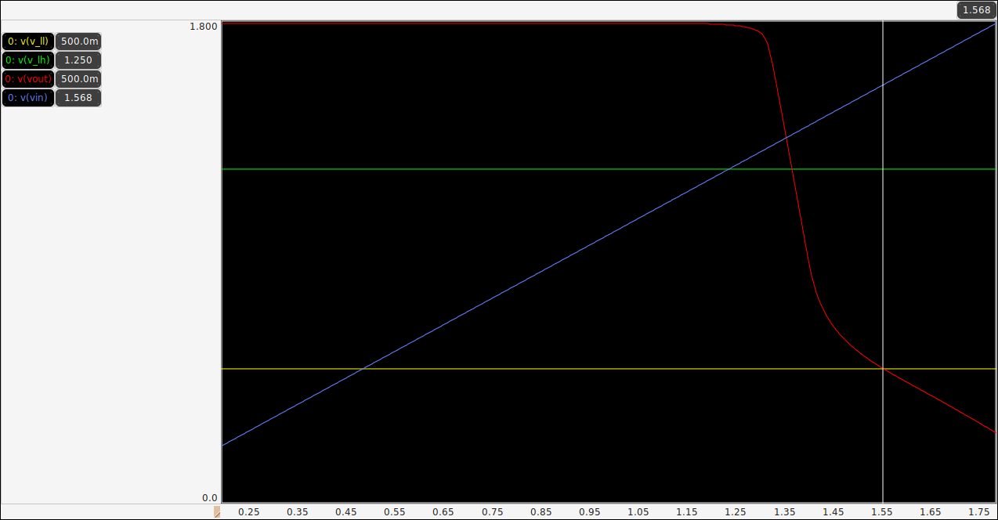

Rest of the figures are similar to the previous figures.

**Th. 13: 1.456:**

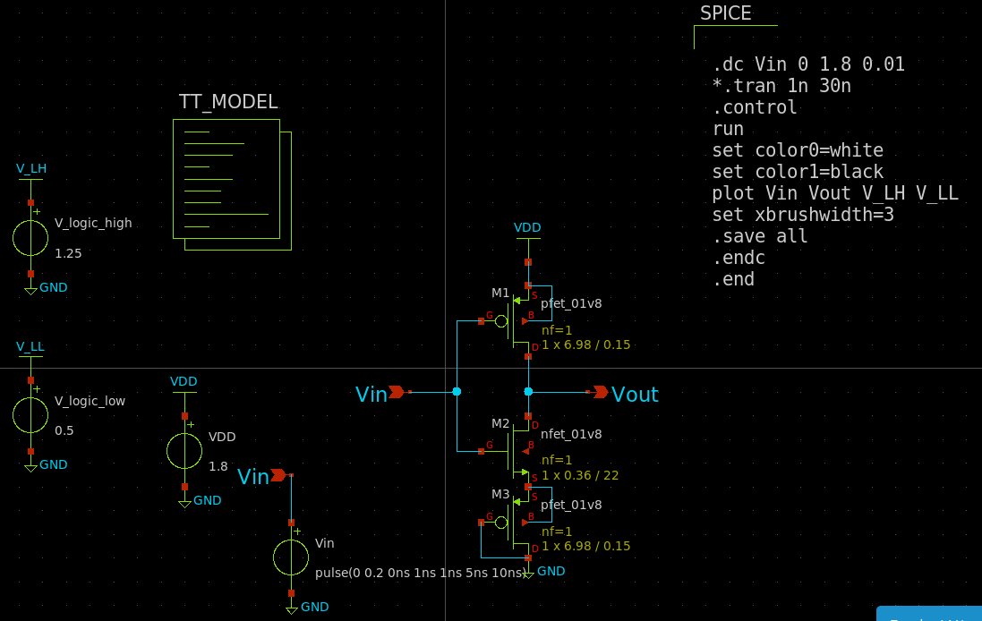

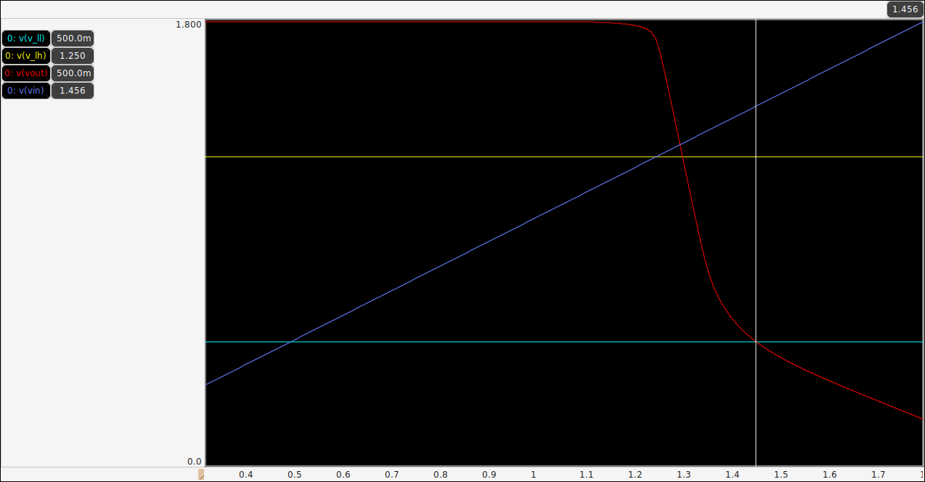

**Th. 12: 1.344**

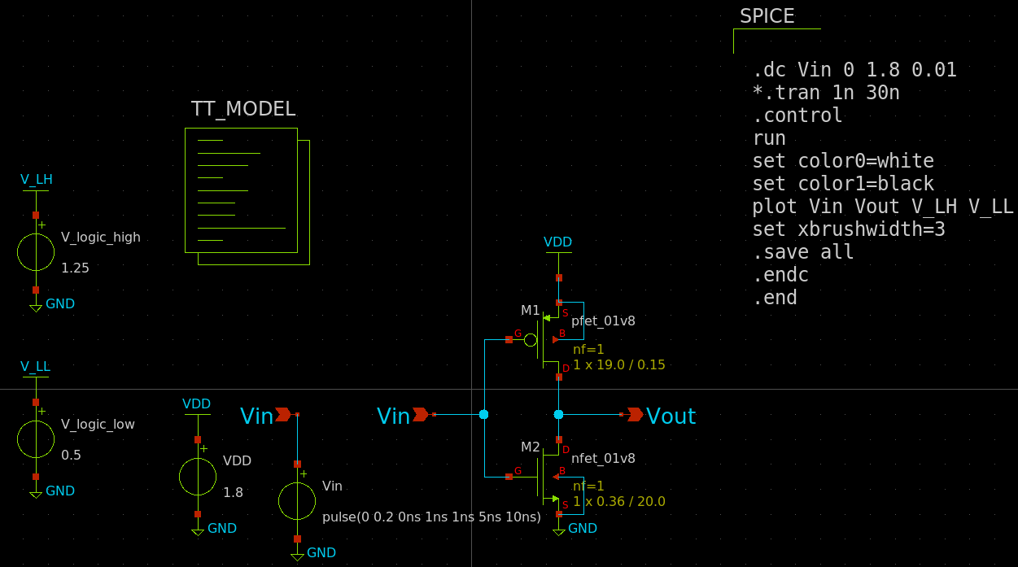

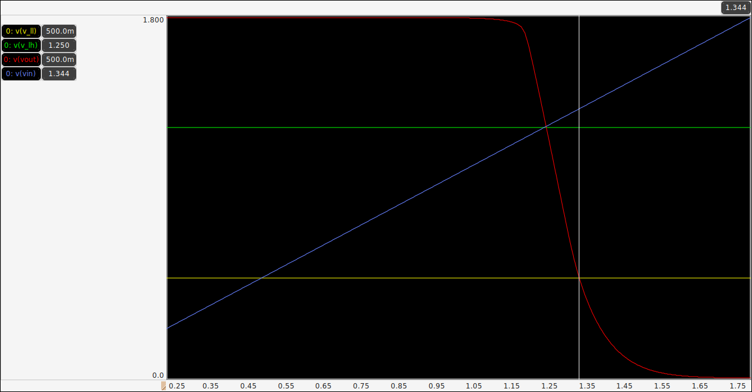

**Th. 11: 1.232**

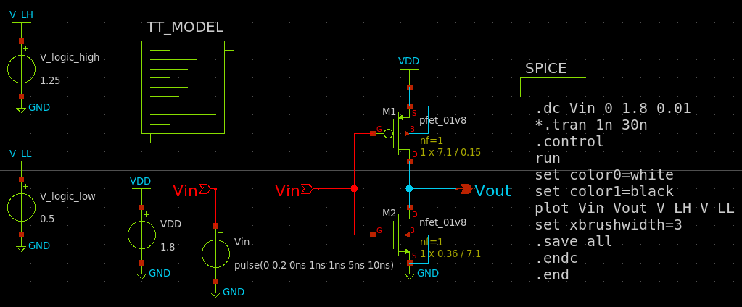

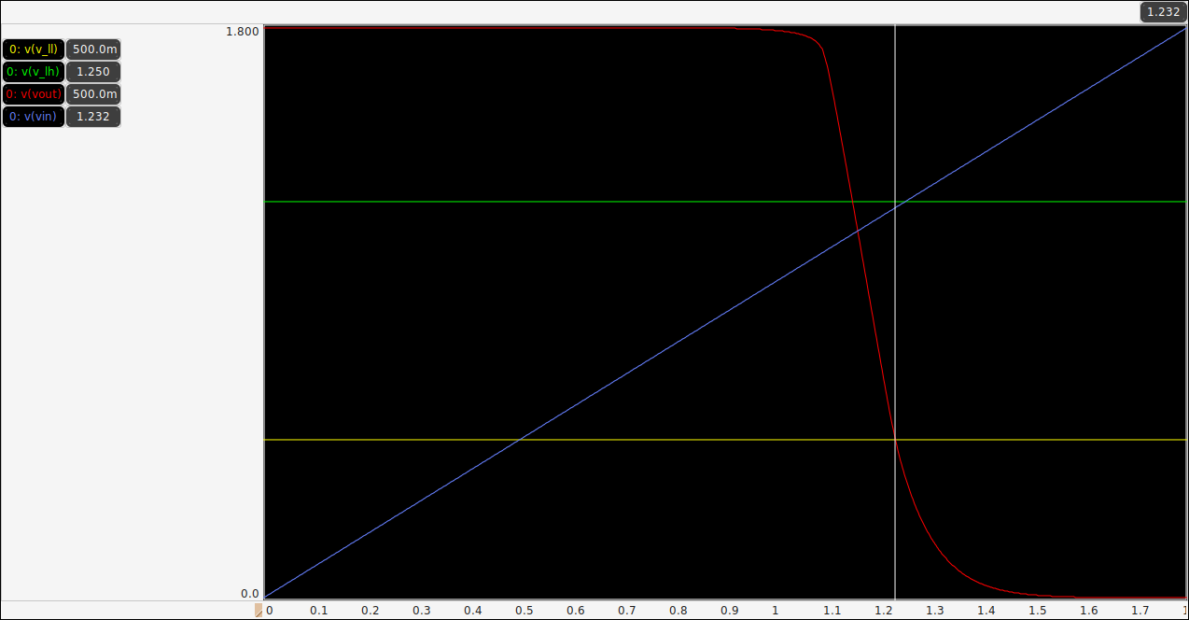

**Th. 10: 1.12**

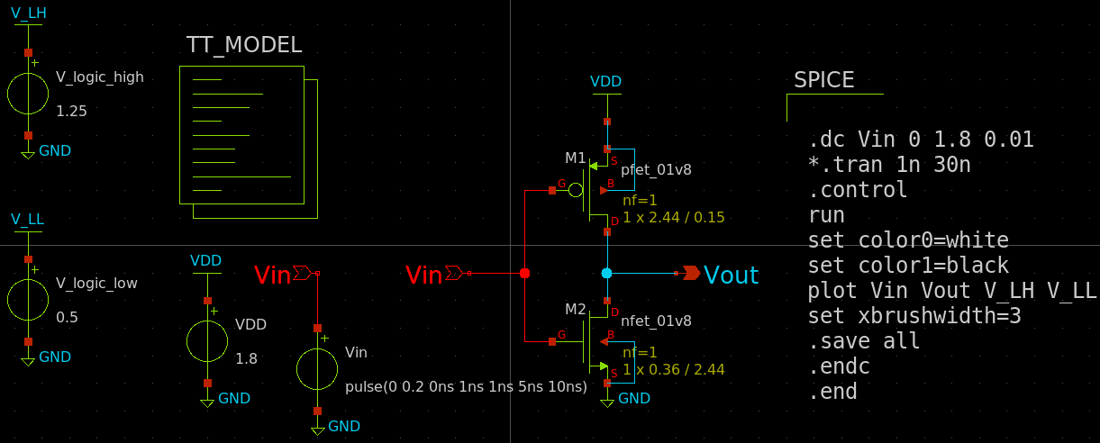

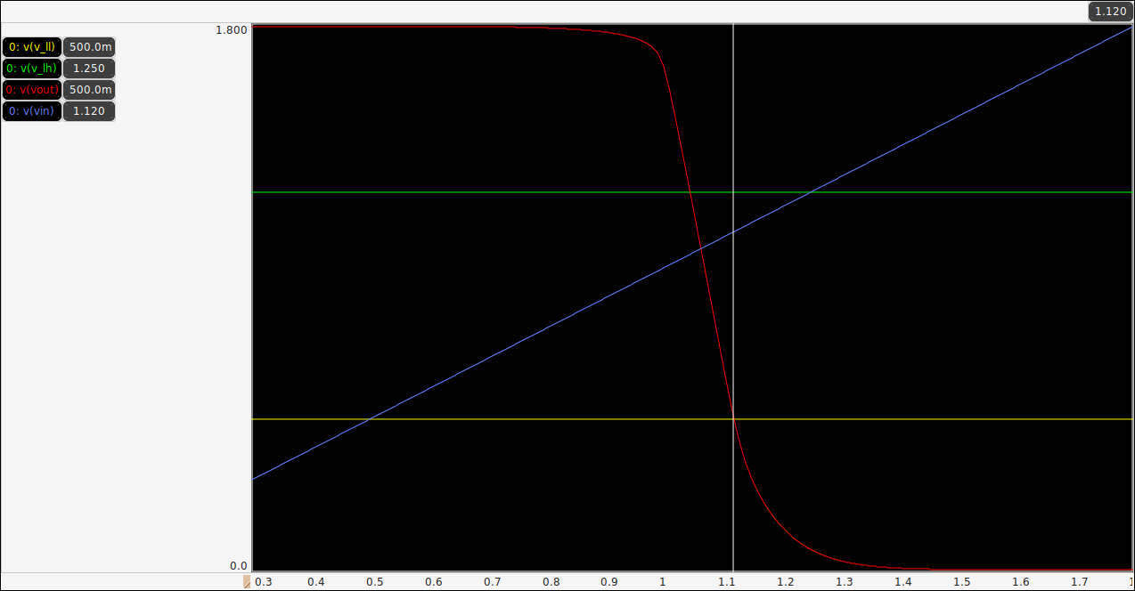

**Th. 9: 1.008**

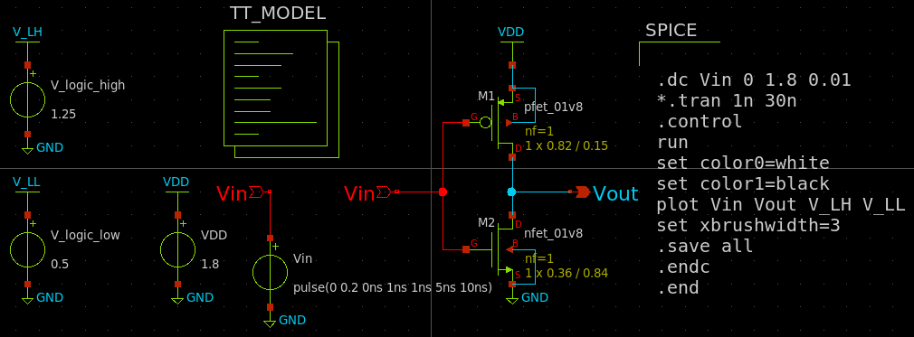

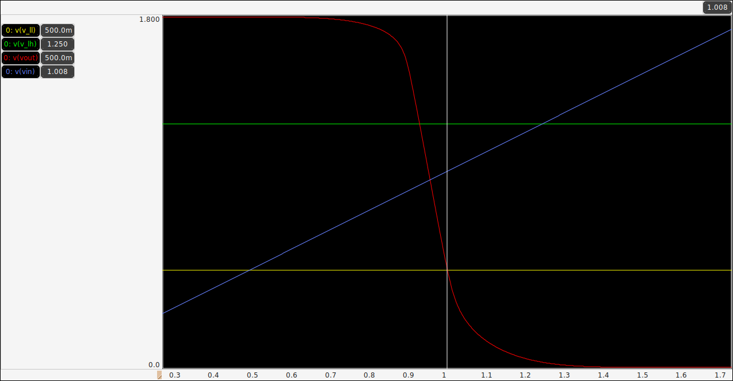

**Th. 8: 0.896**

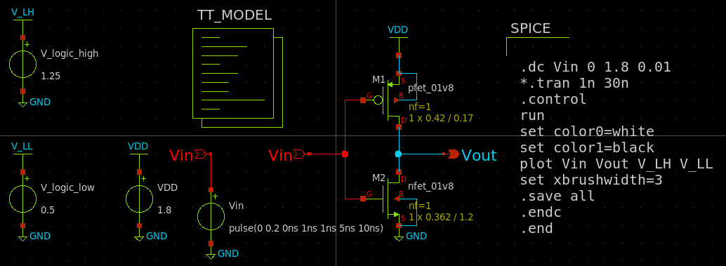

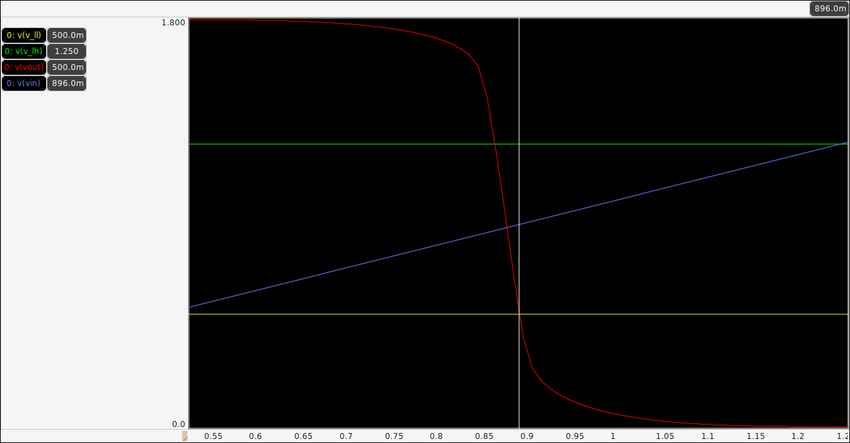

**Th. 7: 0.784**

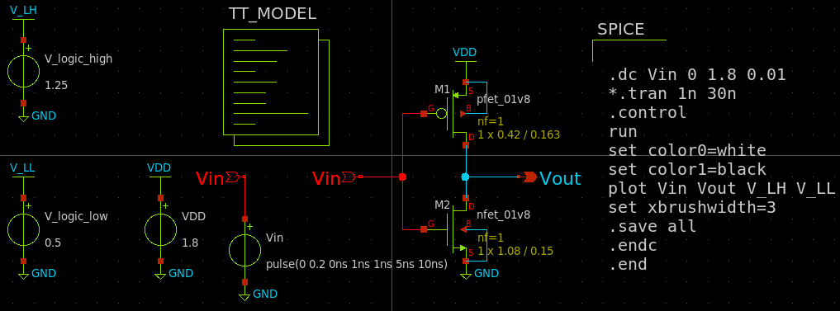

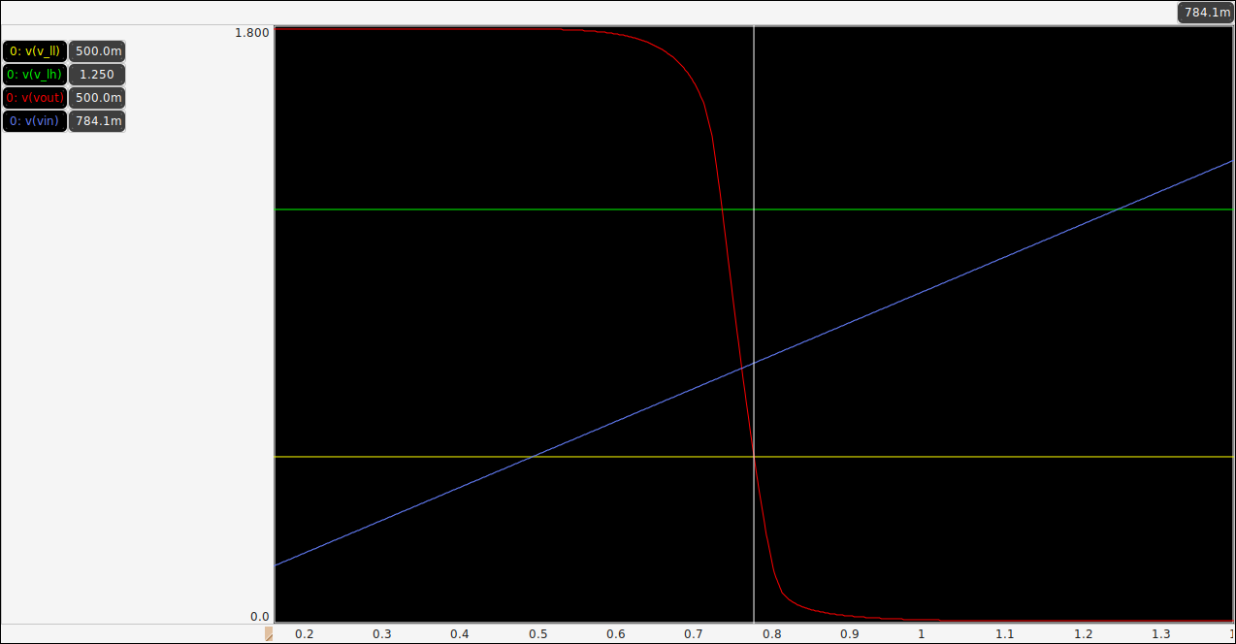

**Th. 6: 0.672**

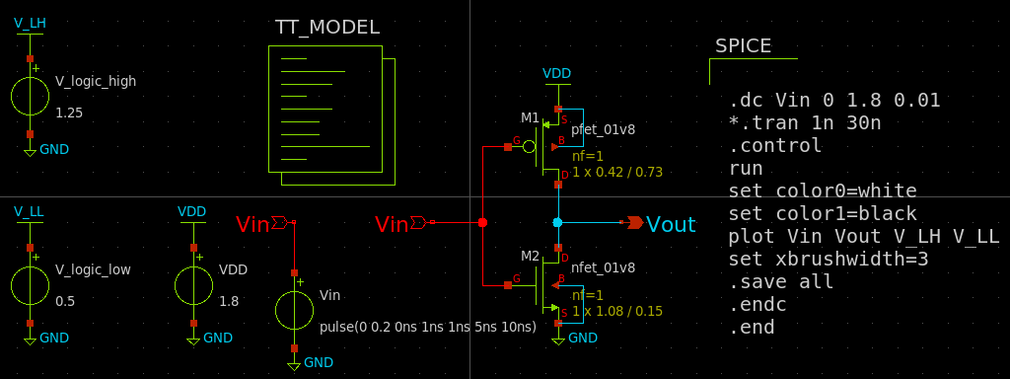

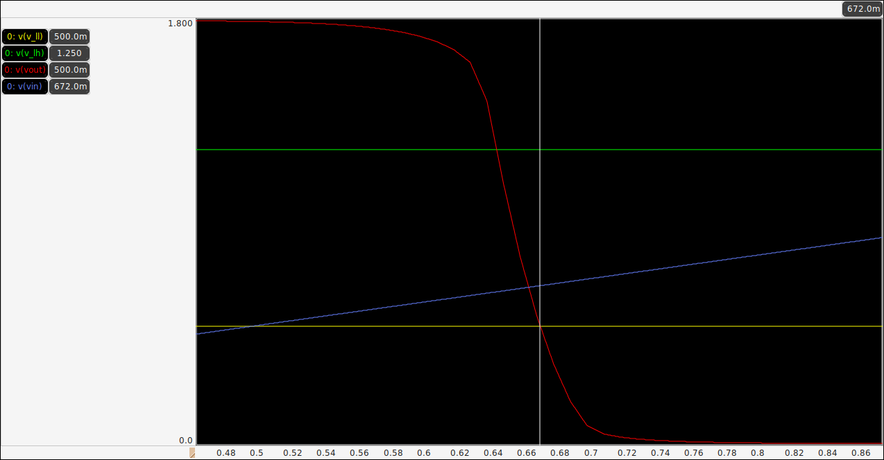

**Th. 5: 0.56**

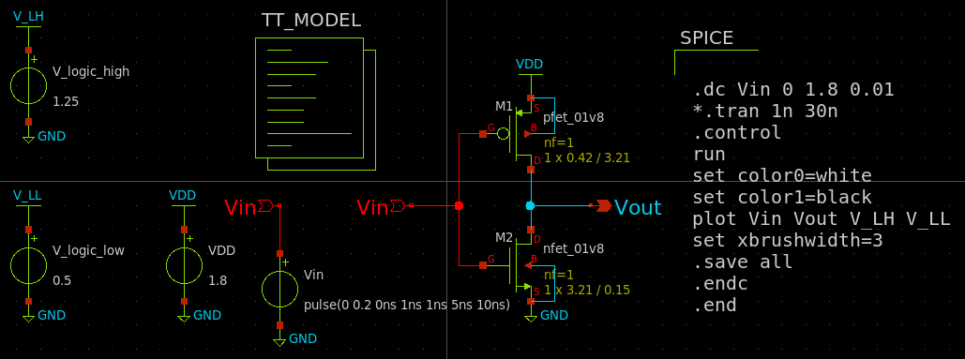

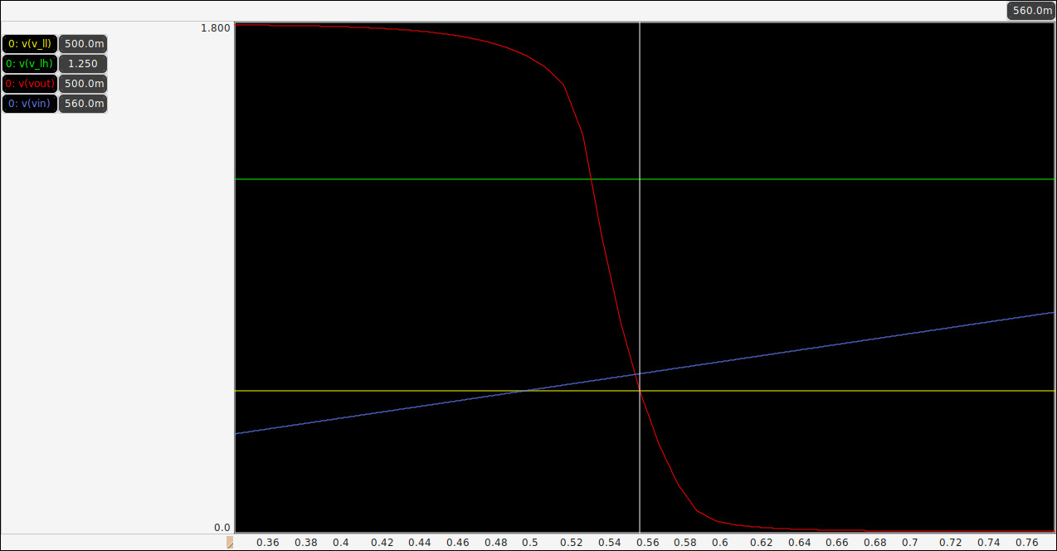

**Th. 4: 0.448**

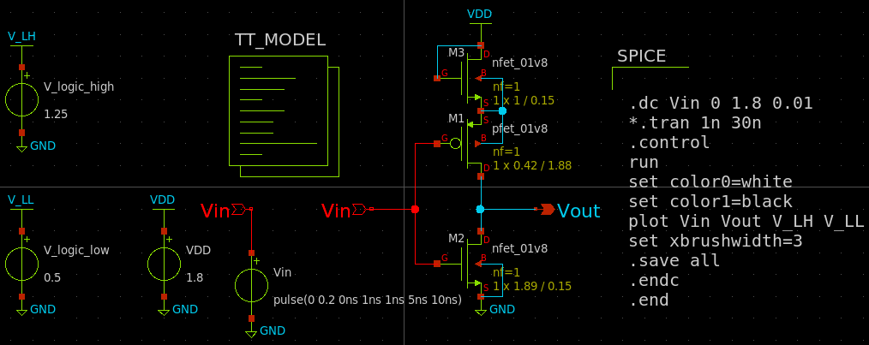

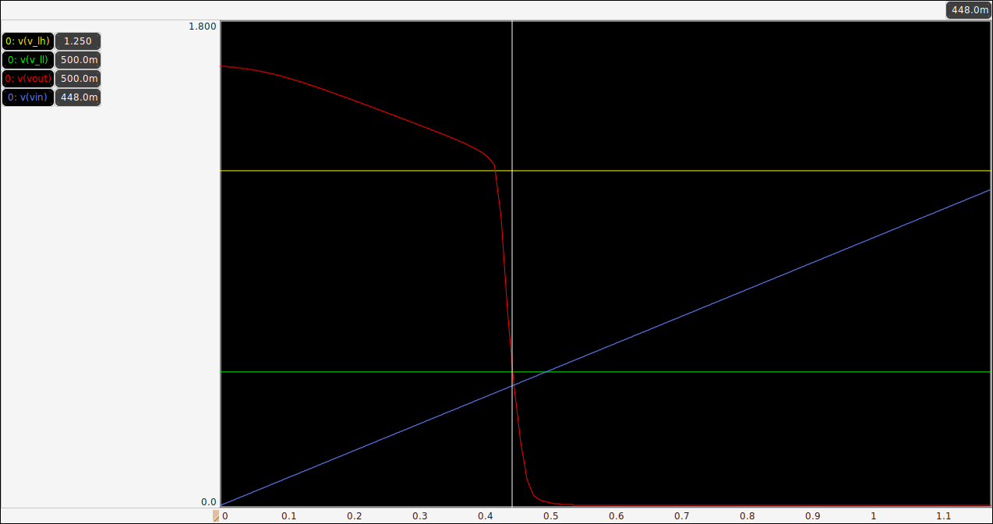

**Th. 3: 0.336**

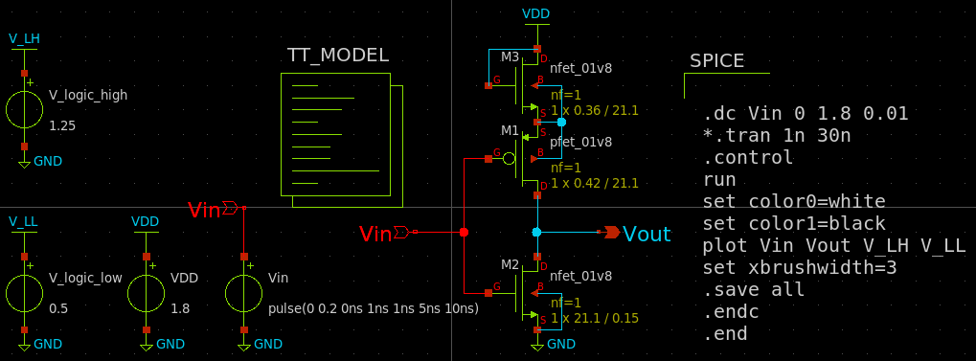

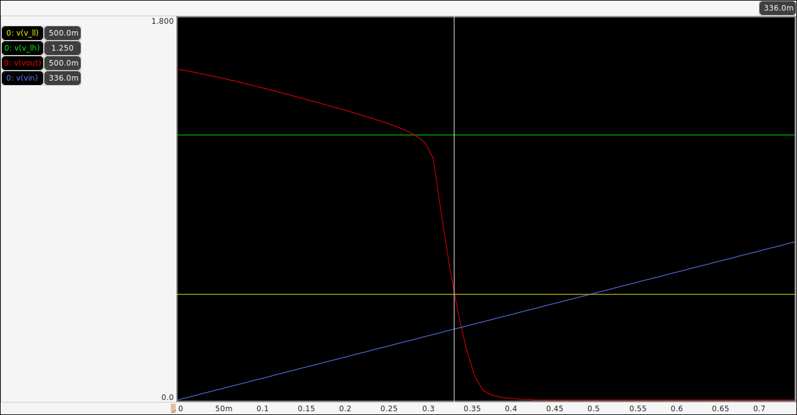

**Th. 2: 0.224**

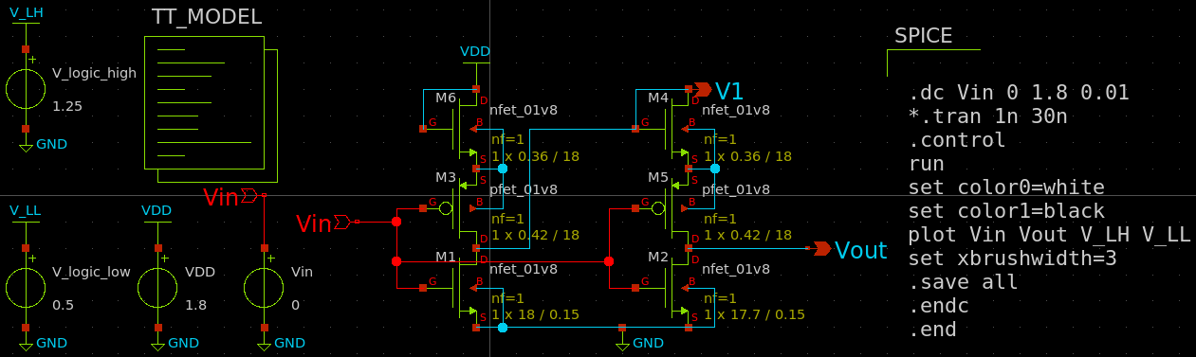

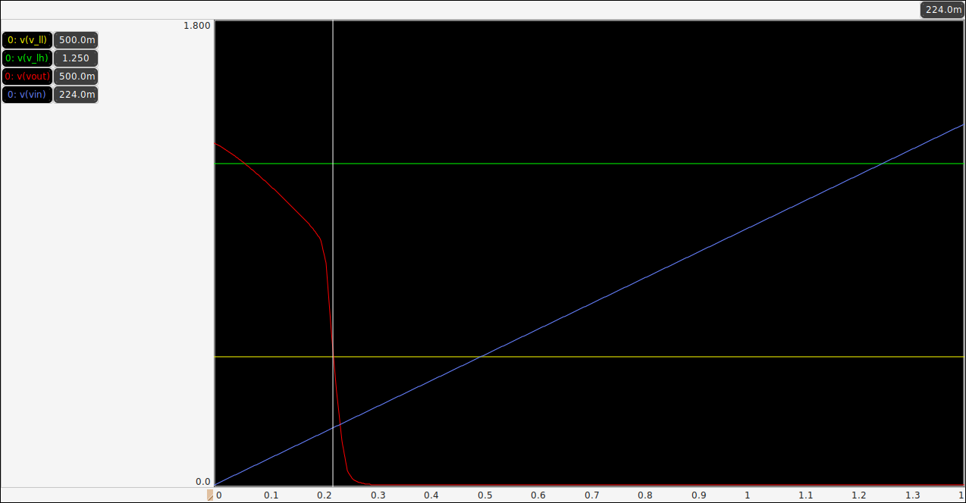

**Th. 1: 0.112**

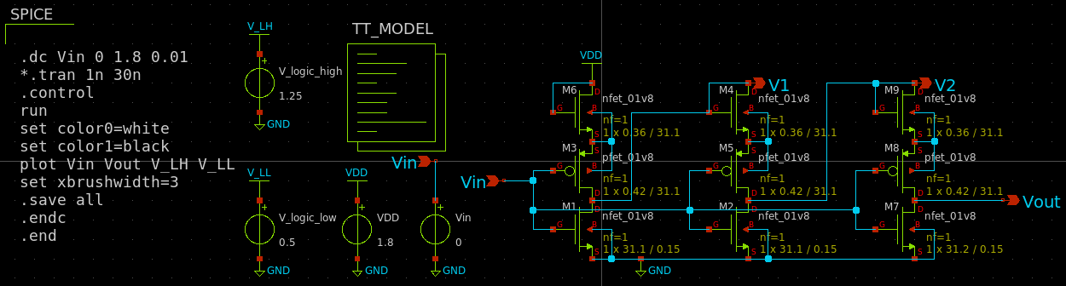

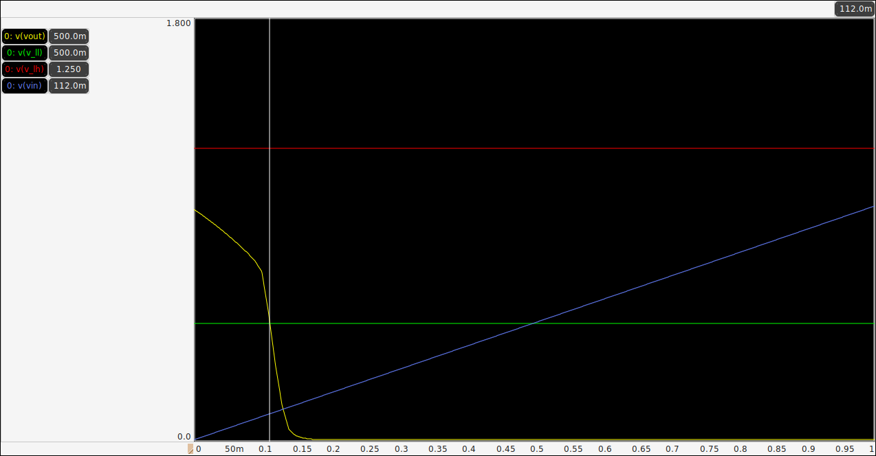

**Combined Analog sch.**

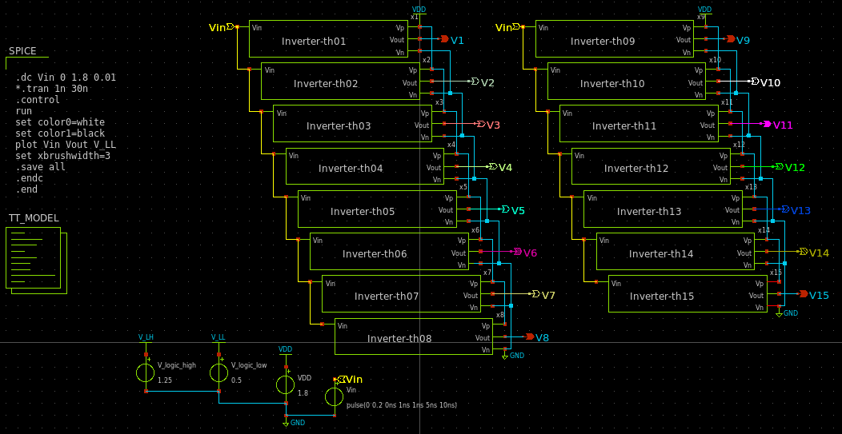

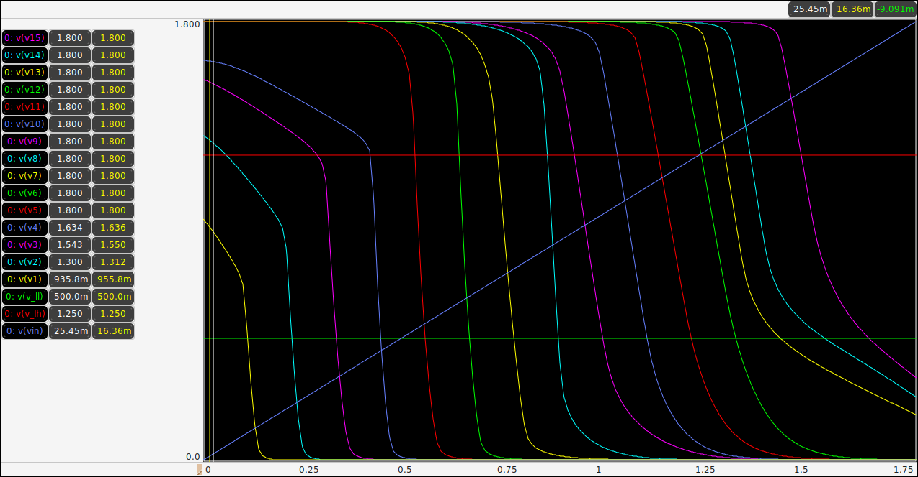

<http://web02.gonzaga.edu/faculty/talarico/vlsi/xschemTut.html>

<https://ngspice.sourceforge.io/ngspice-control-language-tutorial.html>

**Alter subckt tutorial**—

<https://sourceforge.net/p/ngspice/discussion/133842/thread/5ad086c79f>

<https://sourceforge.net/p/ngspice/discussion/133842/thread/9a75acf2/#bf90/45b3/ea48>

**Pyspice ngspice interpreter**

https://pyspice.fabrice-salvaire.fr/releases/v1.3/examples/ngspice-shared/ngspice-interpreter.html

https://github.com/ashwith/ngspicepy

**Read spice raw output data**

https://gist.githubusercontent.com/snmishra/27dcc624b639c2626137/raw/742fe0dd59c7b2c41b71a1c8c1c2506d13affc53/rawread.py

**ngspice wrapper for python**

https://github.com/eps82/lyngspice/wiki

- write some verilog code to convert the thermometer code (from the inverter stages) into the binary code

<http://www.asic-world.com/verilog/veritut.html>

<https://www.youtube.com/playlist?list=PLfGJEQLQIDBN0VsXQ68_FEYyqcym8CTDN>

<https://github.com/Swagatika-Meher/msvsd2bitcomp>

<https://www.youtube.com/playlist?list=PLvXKBnlvcSm30Y0zu1765oG_x-ECU8tVG>

<https://learning.edx.org/course/course-v1:HarveyMuddX+ENGR85A+3T2021/home>

<https://www.vlsiuniverse.com/digital-thermometer-code-in-verilog-vhdl-flash-adc-binary-encoder/>

<https://www.classcentral.com/subject/vlsi?free=true>

<https://www.eng.biu.ac.il/temanad/digital-vlsi-design/>

<https://www.youtube.com/playlist?list=PLZU5hLL_713x0_AV_rVbay0pWmED7992G>

<https://youtu.be/BIqLk23hE90?list=PLZU5hLL_713x0_AV_rVbay0pWmED7992G>

- get familiar with the yosis syntesis tool to convert the verilog code into a CMOS circuit  
- simulate the complete (ultra small) ADC

References:

<https://github.com/bluecmd/learn-sky130/blob/main/schematic/xschem/getting-started.md>

* What is Schematic Capture and why do we need it?
* What is a process?

**-----------------**

**Run iverilo/icarus**

iverilog file.v

vvp a.out

---------------------------

**Vdd = 5 Volt**

Vsat_max = 4.616

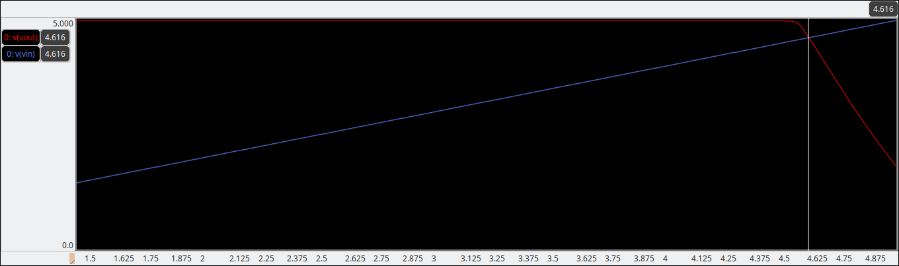

Vsat_min = 481.3mV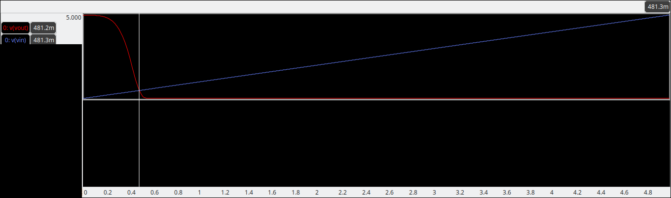

Voltage range = 4.616 – 0.4813 = 4.1347 V

Step voltage = 4.1347/15 = 0.275647

Set. 1: 0.4813

Set. 2: 0.756947

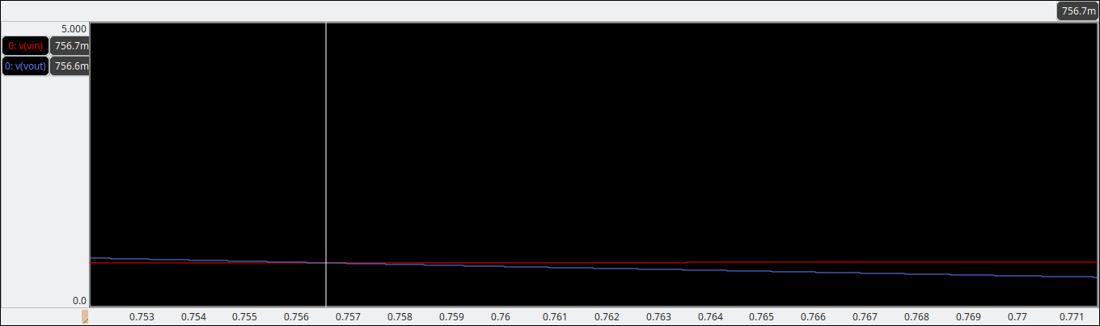

Set. 3: 1.032594

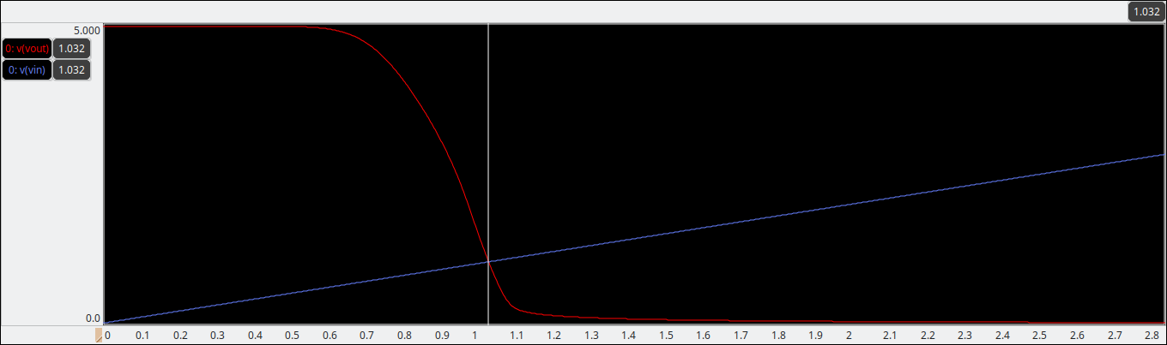

Set. 4: 1.308241

Set. 5: 1.583888

Set. 6: 1.859535

Set. 7: 2.135182

Set. 8: 2.410829

Set. 9: 2.686476

Set. 10: 2.96212

Set. 11: 3.23777

Set. 12: 3.513417

Set. 13: 3.789064

Set. 14: 4.064711

Set. 15: 4.340358

Set. 16: 4.616005